Note on TECHNECO ELGA HYBRID HEAT PUMP

# System selection

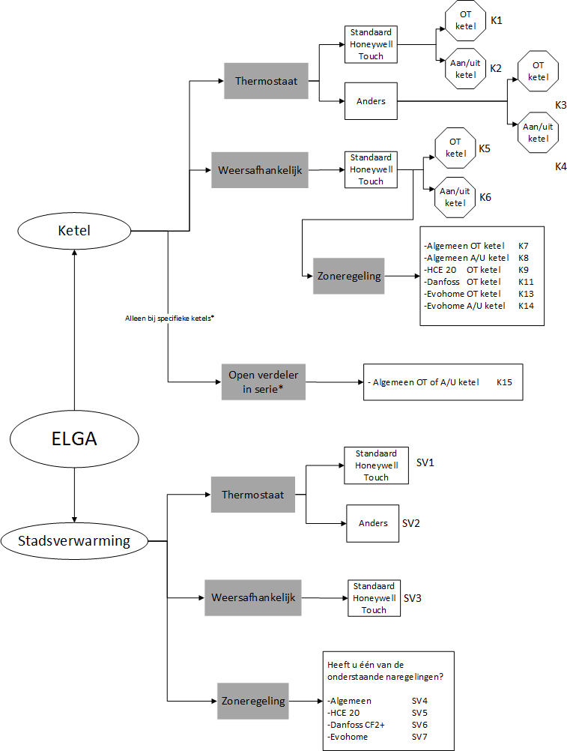

Figure 3-1 shows a flowchart that offers the possibility to easily and quickly make a choice in the system design and the corresponding wiring diagram. For more information and explanation of the installation, please refer to the chapters referred to in the flow diagram. These chapters can be found at the back of the manual.

⚠ **Please note!**  Is a hydraulic separation used for district heating? Then also add an overflow and expansion provision to the installation if they are not yet ready.

##### Figure 3-1

*see section 6.2 for more information

According to figure 3-1, there is no open Theem direct connection with the Heat Pump

# Connection of boiler and thermostat

This chapter describes how to connect the thermostat and boiler to the Elga indoor unit.

* + - **Step 1:** Place the thermostat according to the supplied manual.
    - **Step 2:** Pull a two-wire weak current calyte from the thermostat to the Elga.
    - **Step 3:** Pull a two-wire weak current cable from the Elga to the boiler or district heating valve.
    - **Step 4:** Place the supplied tube clamp sensors NTC1 and NTC2 in the central return line and central supply line respectively. See chapter 17 for the exact locations.
    - **Step 5:** Connect the thermostat, boiler and temperature sensors to the green 13-pin plug on the bottom/inside of the Elga. See Figure 6-1.

⚠ **Please note!**  Use a low current cable of at least 2x0.14 mm2 and a maximum resistance of 2x5 Ω

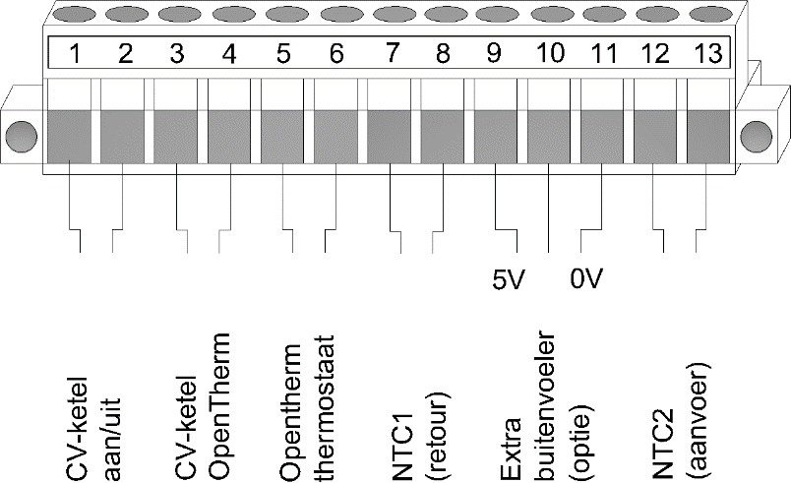

##### 

##### Weather-dependent control

To control weather-dependent, an additional outdoor temperature sensor must be placed (from the sun and on the north façade) and Elga and the supplied thermostat must be configured correctly. See chapter 11.

## Boiler compatibility

The Elga can be combined with any brand and type of gas boiler. The Elga can control the central heating boilers via the OpenTherm protocol or release them via an on/off contact. The rule is to use it if the boiler has an OpenTherm connection. If the boiler does not have an OpenTherm connection, it can be controlled by on /off. A number of exceptions apply to this.

Visit: [https://techneco.nl/do](https://techneco.nl/documentatie-elga-hybride-warmtepomp/) [cumentation-elga-hybrid heat pump/](https://techneco.nl/documentatie-elga-hybride-warmtepomp/) and select the Elga design manual.

If your boiler is not listed and you are sure that it can or cannot be connected to the Elga via OpenTherm, we would appreciate it very much if you inform Techneco of this.

# Interface

In this chapter the ministry of the Elga is described. The Elga can be read in three different ways. Firstly, a display is mounted on the front of the Elga indoor unit. Secondly, the supplied thermostat can be used and thirdly, the various LEDs can be read on the Elga circuit board.

## Display

A display is mounted on the front of the Elga indoor unit. This display shows two control buttons and five symbols, see Figure 7-1.  The table below explains the functions of the buttons and the meaning of the symbols.

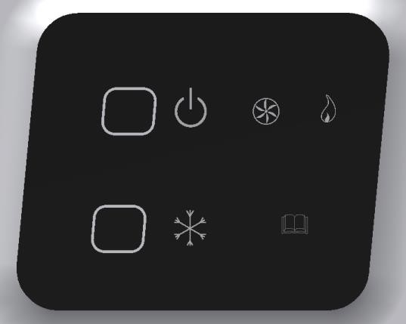

|  |  |  |
| --- | --- | --- |
| **Symbol** | **Function** | Button 1  Button 2  **Figure 7-1** |
|  | **Button 1: On/Off (red LED)**  LED on: the heat pump is switched on and will function together with the boiler for heating.  LED off: the heat pump is switched off. For heating, only the central heating boiler will be used.  LED flashing: Elga is externally blocked for heating. Or the scheme is starting up. |
|  | **Button 2: Release cooling (blue LED)**  LED on: the heat pump can be used for cooling. LED off: The heat pump cannot be used for cooling. LED flashing: Elga is externally blocked for cooling. |
|  | **Operating indication outdoor unit (green LED)**  LED on: the outdoor unit is in operation. LED off: the outdoor unit is in standby. |
|  | **Operating indication boiler (orange LED)**  LED on: the boiler is in operation. LED off: the boiler is in standby.  LED flashes: there is enough demand to use the boiler, but the boiler is off because, for example, the water temperature has reached the set point. See chapter 9.3 |
|  | **Interference (yellow LED)**  LED off: the Elga has no malfunction.  LED flashing: The Elga has a malfunction and is locked.  In case of malfunction, switch off the Elga with button 1. See chapter 12 for more information. |

## http://shop.cvkoopjes.nl/19884-large/honeywell-chronotherm-touch-modulation-klok-thermostaat.jpgThermostate

The standard supplied thermostat is the Honeywell Chronotherm Touch Modulation, shown in Figure 7-2.  For instruction on how to operate the thermostat, the manual that comes with the thermostat can be guessed.

##### Figure 7-2

**Changing installer settings**

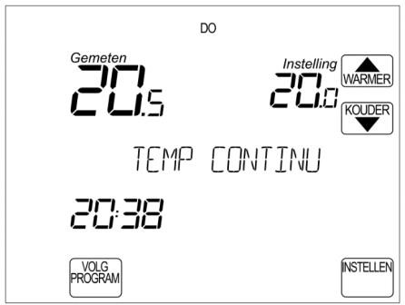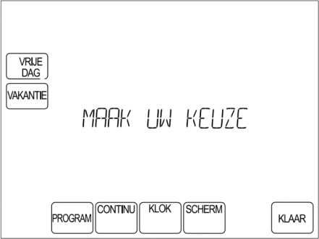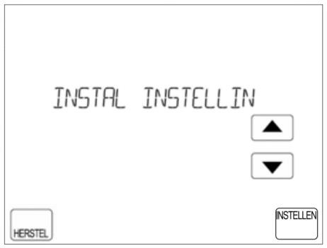

|  |  |  |
| --- | --- | --- |
| Step 1  Press **SET.** | Step 2  Keep the blank box between **SCREEN** and  **READY** for at least 5 seconds.  *5 seconds* | Step 3  Choose "INSTAL INSTELLIN" or the menu erbo- ven "INSTAL KETEL" (see chapter 19.1).  Next menu "BOILER SETTING" |

## LEDs and DIP switches on Elga circuit board

Figure 7-3 shows the Elga circuit board. The figure shows the meaning of the different LEDs present on the printed circuit board. With the help of these LEDs, the status of the heat pump can be easily determined.  Figure 7-4 zooms in on the DIP switches and briefly describes the function of the different switches. The positions displayed on the DIP switches are the default factory settings.

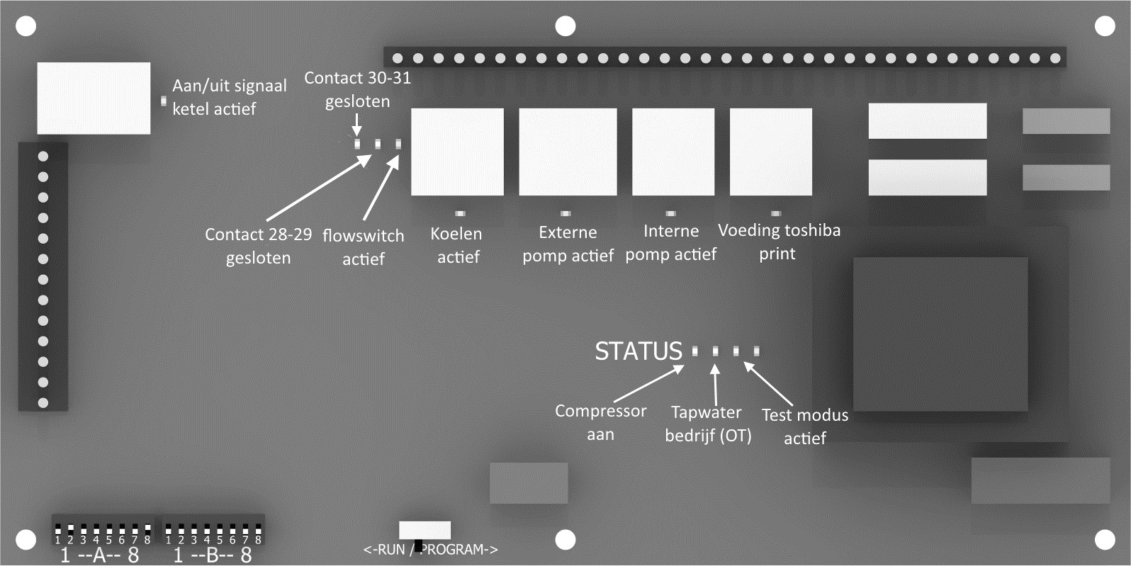

##### Figure 7-3

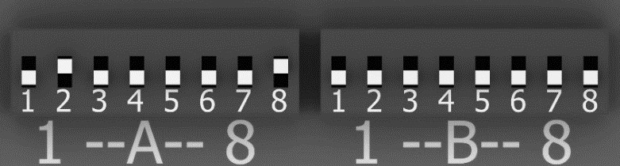

**Figure 7-4**

|  |  |  |
| --- | --- | --- |
| **DIP** | **OFF (to front print)** | **ON (to back print)** |
| A1. | Heating line low | Heating line high |
| A2. | Elga and central heating boiler not active at the same time | Elga and central heating boiler also active simultaneously |
| A3 | Radiator delivery system | Underfloor heating delivery system |
| A4 | Reduced desired room temperature ≤ 19°C Elga and central heating boiler can be used | Reduced desired room temperature ≤19°C only Elga usable |
| A5 | Sleep mode is turned off | Sleep mode is on |
| A6 | Thermostat supports cooling | Thermostat does not support cooling |
| A7 | N/a. | N/a. |
| A8 | Central heating boiler type OpenTherm control | Central heating boiler type on/off control |

|  |  |  |
| --- | --- | --- |
| **DIP** | **OFF (to front print)** | **ON (to back print)** |
| B1. | No extra outdoor sensor | External outdoor sensor applied |
| B2 | Weather-dependent control off | Weather-dependent control on |
| B3. | Parallel connection of the Elga | Serial connection of the Elga |
| B4. | N/a. | N/a. |
| B5. | N/a. | N/a. |
| B6. | If heating is blocked via an external contact, the central heating boiler will switch on immediately | If heating is blocked via an external contact, the central heating boiler will not switch on |
| B7. | External contacts 28 to 31 are blocking contacts | External contacts 28 to 31 are release contacts |
| B8. | Heat pump switches off below the set external temperature limit (standard 4°C) | Heat pump may remain on below the set external temperature limit |

**Explanation dipswitches**

|  |  |
| --- | --- |
| **DIP** | **Definition** |
| A1. | Choice of the low or high firing line for the installation; if the house does not reach temperature, the higher heating line can be chosen. See Figure 10-2 for the firing lines. |
| A2. | Choice whether the Elga and boiler can run at the same time. If it is not possible to run the boiler and Elga at the same time, because this causes flow disturbances, the simultaneity can be switched off. |
| A3 | Choice of delivery system; if there is a combination of (high temperature) radiators and underfloor heating in the house, radiators must be chosen. |
| A4 | At a desired room temperature of 19°C or lower, you can choose to rotate the Elga alleen (showers>4°C). The 19°C can be changed with P70 (see chapter 19.2) |
| A5 | If this feature is enabled, power to the Toshiba print will be turned off if there has been no heat or cold demand for a long time. By default, this period is 10 hours. When the Elga goes into sleep mode, the last measured outer temperature remains in the picture. The function reduces the standby consumption of the Elga. |
| A6 | This is a choice whether or not the thermostat can cool automatically. If the thermostat does not support cooling and A6 is set to ON, then the Elga will not see a heat demand as a cooling demand and the Elga will cool as long as the cooling on the front is indicated with button 2. The included Honeywell Touch Modulation supports cooling (see chapter 9.2), so A6 stands  default to OFF. |
| A7 | Must always be set to OFF. |
| A8 | Choice of whether the central heating boiler is controlled via OpenTherm or on/off. |

|  |  |
| --- | --- |
| **DIP** |  |
| B1. | Choose whether an extra outdoor sensor is used. We advise you to apply this if the Elga is used weather-dependent or if the outdoor unit is too much affected by the sun. |
| B2 | With OFF the Elga is thermostatically controlled (see chapter 10) and with ON weather dependent (see chapter 11). |
| B3. | Choice in parallel (OFF, diagrams K1 to K14) or serial (ON, for district heating, scheme SV1 to SV7). See the installation diagrams chapter 18. |
| B4. | Must always be set to OFF. |
| B5. | Must always be set to OFF. |
| B6. | If the Elga is blocked externally, the boiler is also not controlled if the dip switch is set to ON. If the dip switch is set to OFF, the boiler will be controlled immediately in case of heat demand. |
| B7. | With this dip switch on ON, the external contacts become 28 to 31 release contacts (closing contact means release/question) instead of blocking contacts (closing contact means blockage/no question). |
| B8. | With the dip switch on ON, the Elga is no longer switched off below the set outside temperature limit (standaard 4°C). If the dip weight is set to OFF, the Elga below the outside temperature limit will only turn on the boiler. The external temperature limit of the heat pump can be lowered by means of parameter P62 the outside temperature per degree.  framed. For more information go to chapter 9.5. |

